**Sub-recipient Name:** Bridge Intelligence LLC

**Subaward No:** 00000286

**Principal Investigator:** Hooman Parvardeh

**LTBP TSSC**

**Federal Contract # DTFH61-17-D00001**

PROGRESS REPORT NO. 17

For the Period from 3/1/2019 through 3/31/2019

# Accomplishments/Work Performed

The following is a complete account of all accomplishments and work performed on each task during this reporting period.

# Task 1: (Coordination and Meetings between the Rutgers and FHWA LTBP Team)

During this period, Mr. Parvardeh had a few correspondences with the FHWA team over the email.

Number of hours during this period: 1 hours

# Task 2: (Data Gap Analysis)

During this period, Mr. Parvardeh worked on analyzing data from state #1. Mr. Parvardeh completely cleaned the maintenance data from this state and developed a query and visualization tool which allows user to query the data and see different charts to be able to freely answer different questions. Screenshots from this tool is shown below.

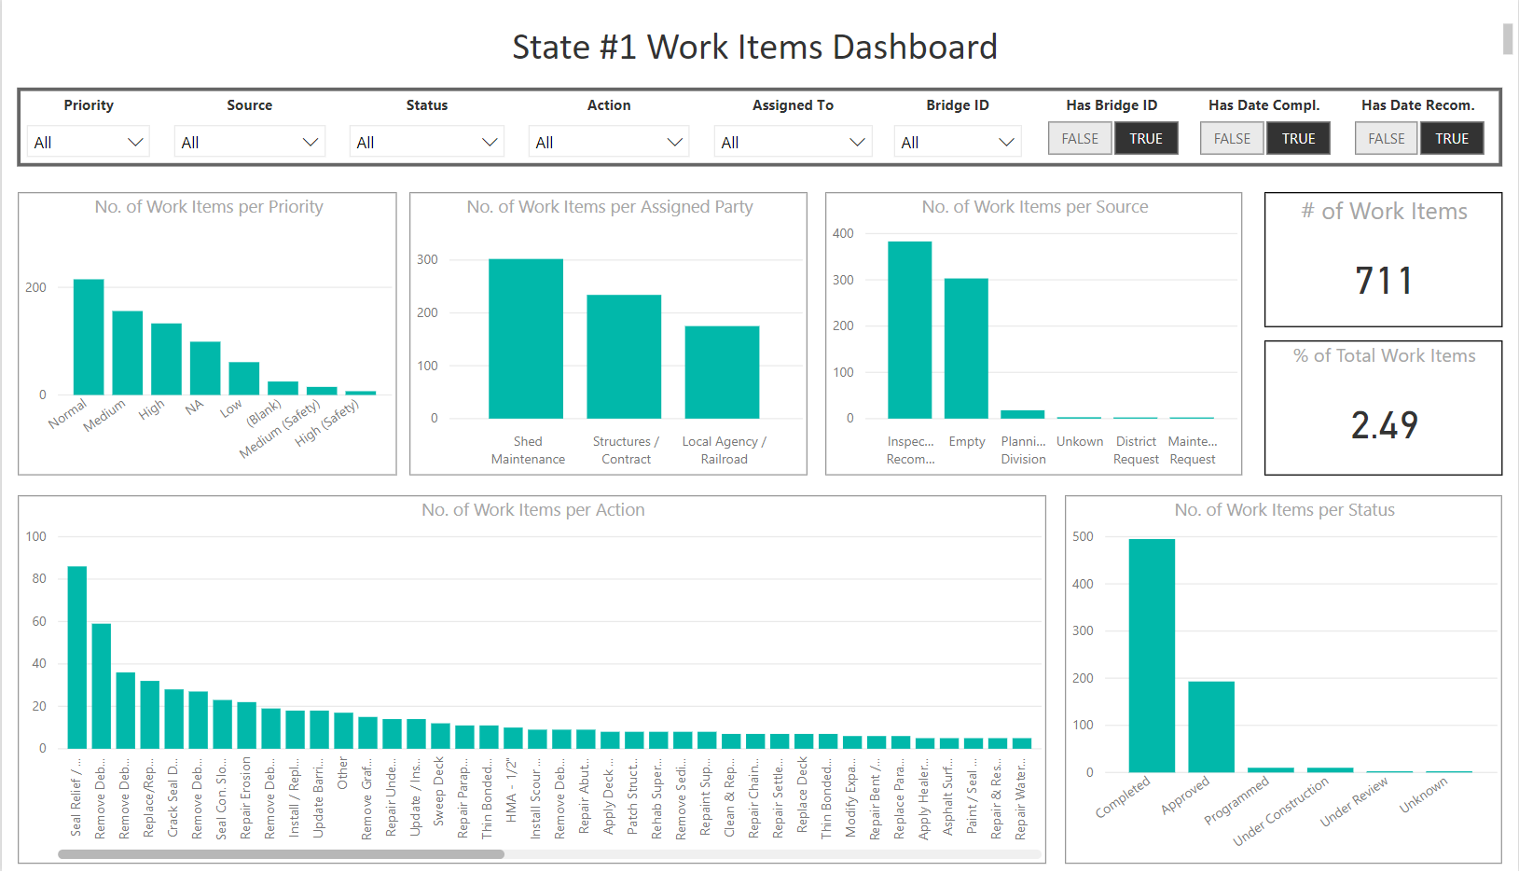

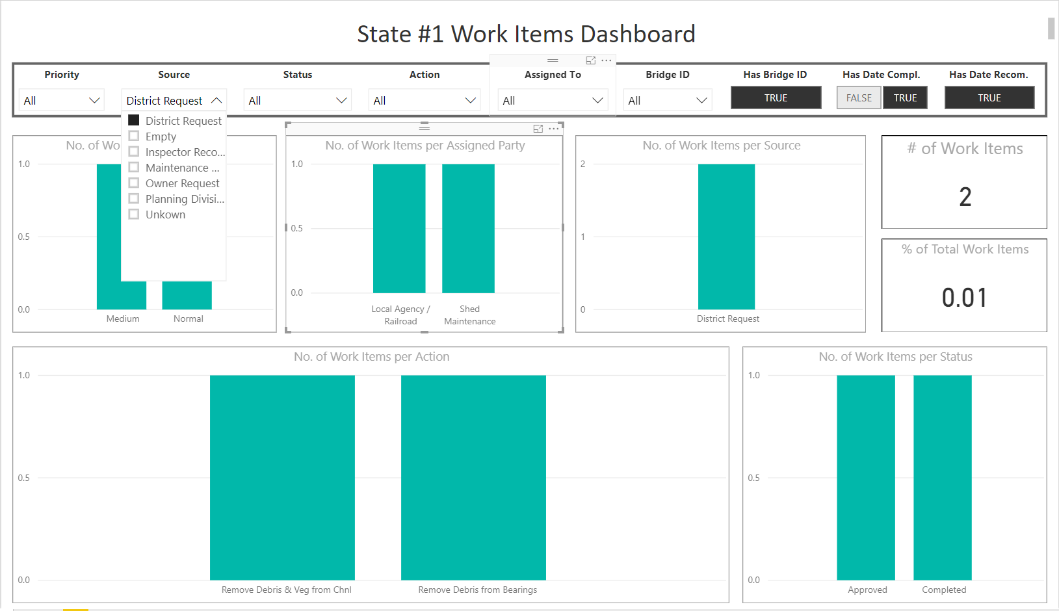

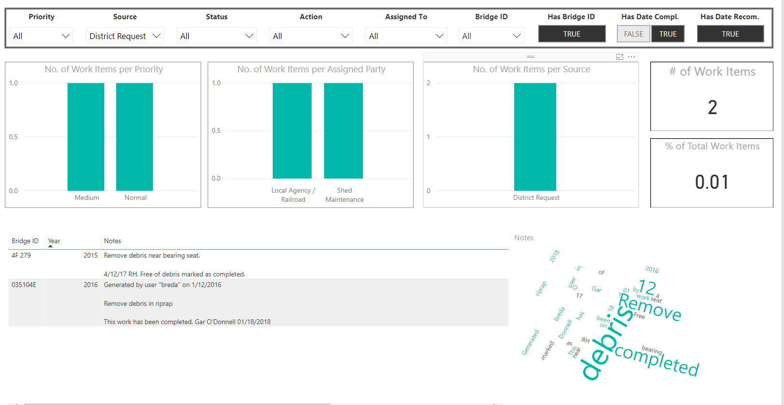

Number of hours during this period: 41 hours

# Task 3: (Communication)

During this period, Mr. Parvardeh performed the following tasks:

* Prepared and submitted monthly progress report to FHWA
* Updated the MS project file and submitted it to FHWA

Number of hours during this period: 10 hours

# Work Anticipated During the Next Period

* Convert maintenance data from state #2 from XML to tabular format.
* Work on the analysis of maintenance data from state #2.
* Develop the Rutgers LTBP progress report and submit to FHWA

# Changes /Problems

None.

# Participants & charged Level of Efforts

|  |  |  |  |
| --- | --- | --- | --- |
| **Personnel Name** | **Role/Contribution** | **Total Hours** | **Billed Cost** |
| Hooman Parvardeh | Principal | 52 | $ 6,760.00 |

Below is a breakdown of level of effort per task:

|  |  |  |
| --- | --- | --- |
| Task 1 | Task 2 | Task 3 |
| 1 hr | 41 hrs | 10 hrs |

# Travel

None.